**Installing Raspberry Pi OS**

The first step is to go to <https://www.raspberrypi.org/software/> and download the Raspberry Pi OS using the Raspberry Pi Imager.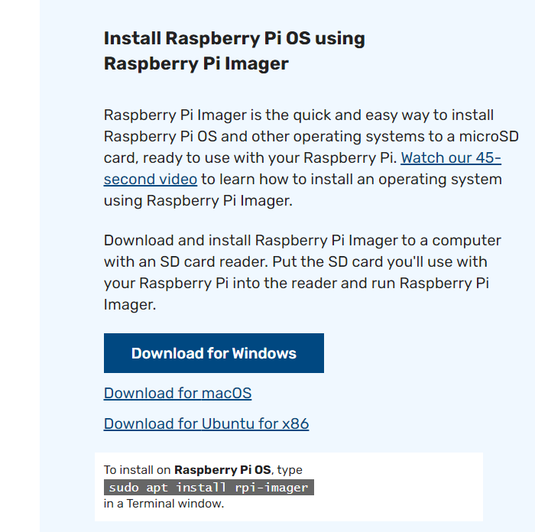

Which you will choose which operating system is on your home computer that you are using to install the OS on the Raspberry Pi.

You will then want to plug in a microSD card through some adapter whether it’s a larger SD card adapter or a USB plug.

**The Imager**

Once the imager is open you will choose the operating system you want to use, you should pick the first option which is a port of Debian.

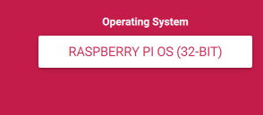

You will then select the storage area, for this you will select your microSD.

Once this is done you will press write. This will install everything necessary for running with your Raspberry Pi.

**On the Pi**

You will then insert your microSD card once it is done installing all of the software into the microSD port, which is located on the opposite side of the Raspberry Pi to the ethernet and USB ports.

Then simply start up the Raspberry Pi and the rest will be installed and the Pi should operate as normal.